A000-AFR-EGY-Ushabti, I-a-n-kh-i, of Per Wadjet-18th dynasty, 1550-1295 BCE

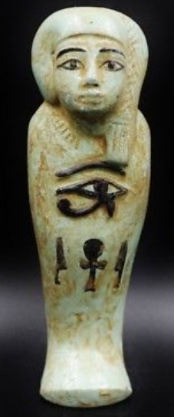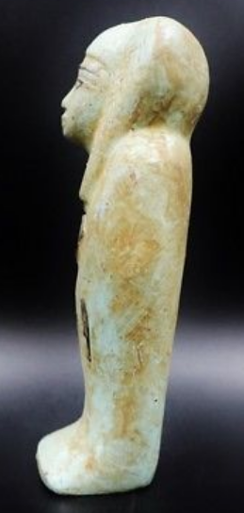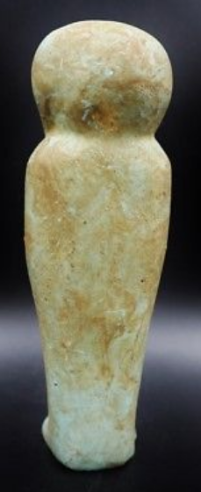

**Case No.: 2**

**Accession No.**

**Formal Label:**

**Display Description:** Funeral servant (ushabti) of high priest of the city of Per Wadjet, I-a-n-kh-I. Another ushabti from this city is in La Musée du Louvre, Inventory no. AF11001.

**Accession Number:**

**LC Classification:** DT62

**Date or Time Horizon:** 18th dynasty, 1550-1295 BCE

**Geographical Area:** Lower Egypt, Nile Delta

**Map:**

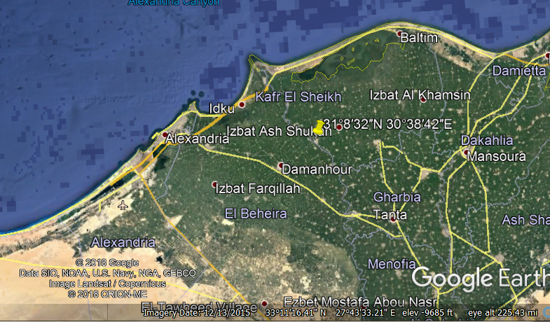

**GPS coordinates:** [31°8′32″N 30°38′42″E](https://tools.wmflabs.org/geohack/geohack.php?pagename=Desouk&params=31_8_32_N_30_38_42_E_region:EG_type:city(137660))

**Cultural Affiliation:** 18th Dynasty of Egypt

**Media:** **faience, white and black pigment**

**Dimensions:** 16 cm x 5 cm x 4.5 cm, 6.3 in x 2 in x 1.8 in

**Weight:** 360 gm

**Condition: original, perfect**

**Provenance:** Ancient House of Canada from an old Canadian collection

**Discussion:**

**References:**